Problem Statement
You work at the United Nations urban-planning unit and need to quantify historical population growth of major cities to inform future resourcing. Starting with Istanbul (one of the world’s fastest-growing metros), calculate the average annual percentage growth rate between 1927 and 2017 using basic R syntax. The same reusable logic should later support any city or time window.

Solution Strategy
1. Store city name and the two endpoint populations in variables. 2. Compute absolute change, convert to percentage growth, then divide by elapsed years (arithmetic mean). 3. Wrap the calculation in a reusable function that also prints a narrative sentence. 4. Provide vector / data-frame alternates and a geometric-rate comparison. 5. Add a simulation block so parameters can be changed interactively.

Solution
Core result (1927–2017): Absolute change = 14 338 231 people; percentage growth ≈ 2 075 %; arithmetic annual growth ≈ 23.06 % per year. Geometric annual growth (more demographically appropriate) ≈ 3.48 %.
Narrative output from function: “From 1927 to 2017 the population of Istanbul, Turkey grew by approximately 23.055525 % each year.”
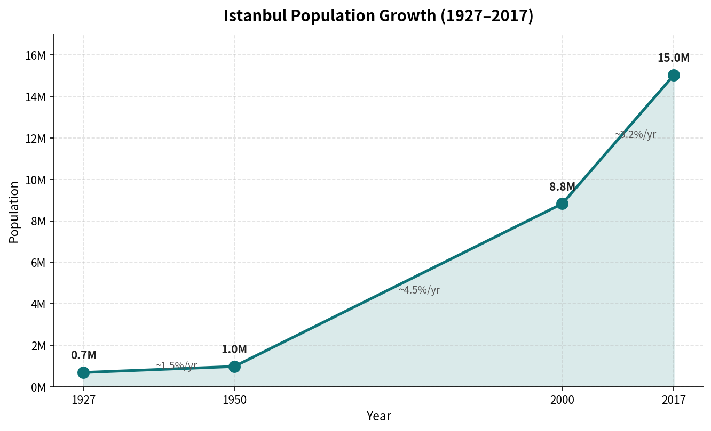
Figure: Istanbul population 1927–2017 (data points labelled in millions).
Period comparison: 1950–2000 ≈ 15.97 %/yr (arithmetic); 2000–2017 ≈ 4.13 %/yr. Mid-century urbanisation produced the steepest arithmetic rates.
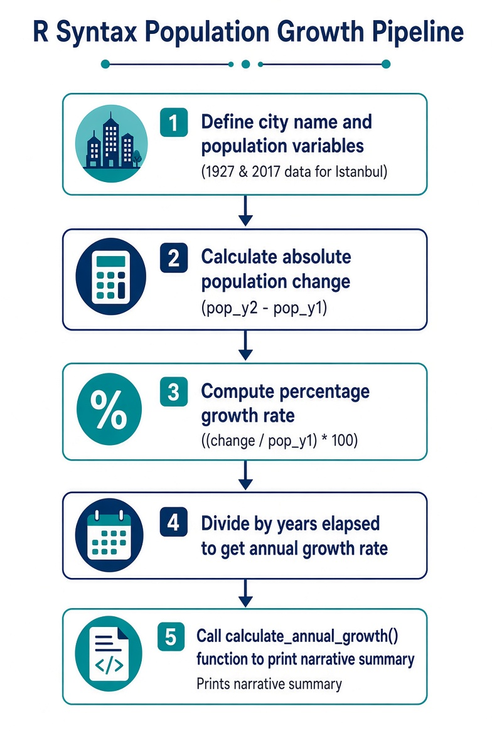
Figure: R Syntax Population Growth Pipeline (flowchart).

Key Takeaways
• Variables + arithmetic operators + paste() are sufficient to turn raw census numbers into an actionable growth narrative.
• Named function arguments and a clear return value make the logic reusable across cities and time windows.
• Arithmetic averages are easy to code but can overstate long-horizon growth; always cross-check with the geometric rate for demographic work.
• A parameterised simulation cell lets planners explore “what-if” futures without rewriting the core calculation.
• Audience note: for UN executives keep the geometric rate and a one-sentence narrative prominent; for technical staff expose both methods and the intermediate variables.

